Roles | Name | Designation | Signature | Date
Author
Reviewer

Approver

Revision History
DCO no. | Revision | Change Description | Author | Effective Date
DCO XXXXX | 01 | Initial Release

- PURPOSE

The purpose of this procedure is to define the process of identifying hazards associated with medical devices, estimating and evaluating the associated risks, controlling these risks and monitoring the effectiveness of the controls.

- SCOPE

This procedure applies to all stages of the life cycle of a medical device manufactured by Kyron Healthcare.

- REFERENCES

  - External Documents
    - ISO 13485:2016
    - ISO 14971:2019 Medical devices — Application of risk management to medical devices.

  - Related Documents

3.2.1 Quality Manual
3.2.2 QS-05-RD Design Control Procedure
3.2.3 QS-15-QA Corrective and Preventive Action Procedure
3.2.4 QS-30-QA Post Market Surveillance Procedure
3.2.5 SS-06001 Design Failure Effect Analysis (DFMEA)
3.2.6 SS-06002 Process Failure Mode Analysis (PFMEA)
3.2.7 SS-06003 Identification of Hazards and Characteristics Related to Safety (IVDR)

- DEFINITIONS

Risk | Combination of the probability of occurrence of harm and the severity of that harm
Residual risk | Risk remaining after risk control measures have been implemented
Hazard | Potential source of harm
Risk Management | Systematic application of management policies, procedures and practices to the tasks of analyzing, evaluating, controlling and monitoring risk
FMEA | Failure Modes Effect Analysis, a risk analysis technique, is a systematic procedure for the analysis of a system to identify the potential failure modes, their causes and effects on system performance

- RESPONSIBILITY
Quality Assurance and Product Development departments are responsible for the contents of this procedure.

- PROCEDURES
  - General Requirements for Risk Management System
    - Risk Management Process
Kyron shall establish, document and maintain throughout the life-cycle an ongoing process for identifying hazards associated with a medical device, estimating and evaluating the associated risks, controlling these risks, and monitoring the effectiveness of the controls. This process shall include the following elements:
      - Risk analysis
      - Risk evaluation
      - Risk control
      - Production and post-production information
Where a documented product realization process exists (e.g. risk management file), it shall incorporate appropriate parts of the risk management process.
Refer to Appendix 1 for schematic representation of the risk management process.

6.1.2 Management Responsibilities
Top management shall provide evidence of its commitment to the risk management process by:
- Ensuring the provision of adequate resources and
- Ensuring the assignment of qualified personal for risk management.

Top management shall:

Define and document the policy for determining criteria for risk acceptability; this policy shall ensure criteria are based upon applicable national or regional regulations and relevant international standards and consider available information such as the generally accepted state of the art and known stakeholder concerns.

Review the suitability of the risk management process at planned intervals to ensure continuing effectiveness of the risk management process and document any decisions and actions taken; this review shall be part of the quality management system review

    - Competence Of Personnel
Persons performing risk management tasks shall have the knowledge and experience appropriate to the tasks assigned to them. These shall include, where appropriate, knowledge and experience of the particular medical device (or similar medical devices) and its use, the technologies involved or risk management techniques. Appropriate qualification records shall be maintained.
The following personnel would be involved, where applicable:
      - Research & Development
      - Quality Assurance & Regulatory Affairs
      - Production
      - Sales & Marketing
      - Clinical Affairs

    - Risk Management Plan

Kyron shall document risk management activities. For the medical device being considered, establish and document a risk management plan in accordance with the risk management process. The risk management plan shall be part of the risk management file.
This plan shall include at least the following:
      - Scope of the planned risk management activities, identifying and describing the medical device and the entire life-cycle phases for which each element of the plan is applicable.
      - Assignment of responsibilities and authorities.
      - Requirements for review of risk management activities.
      - Criteria for risk acceptability, based on Kyron policy for determining acceptable risk, including criteria for accepting risks when the probability of occurrence of harm cannot be estimated.
      - A method to evaluate the overall risk and criteria for acceptability may include literature review, applicable expert judgement and clinical expertise.
      - Verification activities of implementation and effectiveness of risk control measures.
      - Activities related to collection and review of relevant production and post-production information during;
- Product development stage
- Production stage
- Feedback / Complaint
- Adverse database on competitor/similar product
- New or amended standard and jurisdiction regulatory requirements

Should there be any change of plan during the product life cycle, a record of changes shall be maintained in the risk management file.

    - Risk Management File
For each respective medical device model being considered, Kyron shall establish and maintain a risk management file. The risk management file shall be traceable to the medical device. Indicate the product name and model/part number on all risk management documents and records to enable traceability.
In addition to the requirements of this procedure, the risk management file shall provide traceability for each identified hazard to:
- The risk analysis
- The risk evaluation
- The implementation and verification of risk control measures
- The assessment of the acceptability of any residual risk(s)

Content of risk management file:

  - Risk Analysis

Risk Management File | Document
 | Risk Management Procedure
 | Identification of Hazards and Characteristics Related to Safety
 | Risk Management Plan
 | Product and Process Risk Assessment (Eg. FMEA)
 | Risk Management Report
 | Production and Post-Production Information
 | Other documents related

6.2.1 Risk Analysis Process

Risk analysis shall be performed for the medical device as described in points 6.2.2 to 6.2.5 (Eg. The tool used for risk analysis can be Failure Modes Effect Analysis, FMEA). The implementation of the planned risk analysis activities and the results of the risk analysis shall be recorded.

In addition to the records required in points 6.2.2 to 6.2.5, the documentation of the conduct and results of the risk analysis shall include at least the following:
      - A description and identification of the medical device that was analysed.
      - Identification of the person(s) and organization who carried out the risk
analysis.
      - Scope and date of the risk analysis.

6.2.2 Intended Use and Reasonably Foreseeable Misuse
Kyron shall document the intended use and reasonably foreseeable misuse of the product. The intended use should take into consideration like intended medical indication, patient population, part of a body or type of interacted with, user, use environment and operating principle. This documentation shall be maintained in the risk management file.

    - Identification of Characteristic Related to Safety
Kyron shall identify and document those qualitative and quantitative characteristics that could affect the safety of the medical device and, where appropriate, their defined limits. This documentation shall be maintained in the risk management file.

    - Identification of Hazards and Hazardous Situations
Kyron shall identify and compile documentation on known and foreseeable hazards associated with the medical device in both normal and fault conditions. For each identified hazard, Kyron shall consider the reasonably foreseeable sequence or combinations of event that can result in hazardous situation and shall identify and maintain in the risk management file.

Appendix 2 and 3 are examples of hazards and, events and circumstances

6.2.5 Risk Estimation

For each identified hazardous situation, Kyron shall estimate the associate risk(s) using available information or data like the following sources:
- Published standards
- Scientific or technical investigation
- Field data from similar medical devices already in use, including publicly available reports of incidents
- Usability tests employing typical users
- Clinical evidence
- Results of relevant investigation or simulations
- Expert opinion

For hazardous situations for which the probability of the occurrence of harm cannot be estimated, the possible consequences shall be listed for use in risk evaluation and risk control. The results of these activities shall be recorded in the risk management file.

The system used for qualitative or quantitative categorization of probability of occurrence of harm and severity of harm shall be recorded in the risk management file.

Analytical tool Failure Mode Effect Analysis is used to identify and evaluate potential of the design and process.

For Design Risk Analysis, each potential hazard shall be assigned with Severity and Probability of occurrence of risk (Refer to Appendix 4)

For Process Risk Analysis, each process shall be assigned with Severity, Probability of occurrence and Detection level (Refer to Appendix 5).

Both FMEA system shall have their own calculation method using RPN (Risk Priority Number)

RPN = Severity (S) X Probability of occurrence (P) X *Detection (D)

* Not applicable to Design Risk Analysis

  - Risk Evaluation

For each identified hazardous situation, Kyron shall decide estimated risks and determine risk is acceptable or not, using the criteria for risk acceptability in the risk management plan.

If the risk is acceptable, Kyron is not required to apply the requirement in 6.4.1 to 6.4.5 to this hazardous situation (i.e. proceed to 6.4.6) and the estimated risk shall be treated as residual risk.

If the risk is not acceptable, Kyron shall perform risk control activities as described in 6.4.1 to 6.4.6. The results of this risk evaluation shall be recorded in the risk management file.

  - Risk Control
6.4.1 Risk Control Option Analysis

Kyron shall identify risk control measure(s) that are appropriate for reducing the
risk(s) to an acceptable level.

Kyron shall use one or more of the following risk control options in the priority order listed
- Inherent safety by design and manufacture
- Protective measures in the medical device itself or in the manufacturing process
- Information for safety and, where appropriate, training to users.

The risk control measures selected shall be recorded in the risk management file.

If, during risk control option analysis, Kyron determines that required risk reduction is not practicable, Kyron shall conduct a risk/ benefit analysis of the residual risk.

    - Implementation of Risk Control Measure(s)

Kyron shall implement the risk control measure(s) identified in point 6.4.1 Implementation of each risk control measure shall be verified. The verification shall be recorded in the risk management file.

The effectiveness of the risk control measure(s) shall be verified and the results shall be recorded in the risk management file.

    - Residual Risk Evaluation

After the risk control measures are applied, Kyron shall evaluate the residual risk using the criteria defined in the risk management plan.

If the residual risk is not judged acceptable as defined in the criteria, further risk control measures shall be applied, i.e. proceed to point 6.4.1

For residual risks that have been judged acceptable, Kyron shall decide which residual risks to disclose and what information is necessary to include in the accompanying documents in order to disclose those residual risks.

Results shall be recorded in the risk management file and any accompanying documents.

    - Benefit-Risk Analysis
If the residual risk is evaluated to be unacceptable using the criteria established in risk management plan and further risk control is not practicable, the Kyron may gather and review data and literature to determine if the medical benefits of the intended use outweigh the residual risk.

If this evidence does not support the conclusion that the medical benefits outweigh the residual risk, then the Kyron may consider modifying the product of its intended use, then proceed to point risk remains unacceptable. If the medical benefits outweigh the residual risk, then proceed to point 6.2.2. Otherwise, the risk remains unacceptable.

If the medical benefits outweigh the residual risk, then proceed to point 6.4.5.
The results of the benefit-risk analysis shall be recorded in the risk management file.

    - Risks Arising from Risk Control Measures

Kyron shall review the effects of the risk control measures with regard to whether:
      - Introduction of new hazards or hazardous situations
      - The estimated risks for previously hazardous situations are affected by the introduction of the risk control measures.

Any new or increased risks shall be managed in accordance to this procedure (proceed point 6.2.5 to 6.4.4). The results of this review shall be recorded in the risk management file.

    - Completeness of Risk Control

Kyron shall review the risk control activities to ensure that all the risks from all identified hazardous situation have been considered and all risk control activities are completed.

The results of this review shall be recorded in the risk management file.

  - Evaluate Overall Residual Risk
After all risk control measures have been implemented and verified, Kyron shall decide if the overall residual risk posed by the medical device, taking into account the contribution of all residual risks, in relation to the benefits of the intended use, using the method and criteria for acceptability of the overall residual risk defined in the risk management plan. All risk shall reduce to “as far as possible”.

If the overall risk is judge acceptable, Kyron shall inform users of the significant residual risks and shall include necessary information in the accompany documentation (like IFU) in order to disclose those residual risk.

If the overall risk residual is not judged acceptable in relation to the benefits of the intended use, Kyron may consider implementing additional risk control measures (proceed to 6.4.1) or modify product or its intended use (proceed to 6.2.2). Otherwise, the overall residual risk remains unacceptable.

Alternatively, Kyron may gather and review data and literature to determine if the medical benefits of the intended use outweigh the overall residual risk. If this evidence supports the conclusion that the medical benefits outweigh the overall residual risk, then the overall residual risk can be judged acceptable on the condition that it has been reduced “as far as possible”. Otherwise, the overall residual risk remains unacceptable.

The results of this review shall be recorded in the risk management file.

  - Risk Management Review

Prior to release for commercial distribution of the medical device, Kyron shall carry out a review of the risk management process. This review shall at least ensure that
      - The risk management plan has been appropriately implemented.
      - The overall residual risk is acceptable.
      - Appropriate methods are in place to obtain relevant production or post-production phrase.
The results of this review shall be recorded in the Risk Management Report and included in the Risk Management File.

The responsibility for review should be assigned in the Risk Management Plan, to persons with appropriate authority.

  - Production and Post-Production Activities

Kyron shall establish, document and maintain a system to collect and review information about the medical device or similar devices in the production and the post- production phases.
When establishing a system, Kyron shall consider the appropriate methods for collection and processing of information.

6.7.1 Information Collection

Kyron shall collect, where applicable:
- Information generated during production and monitoring of the production process
- Information generated by user
- Information generated by those accountable for installation, use and maintenance of the medical device.
- Information generated by supply chain
- Publicly available information, like adverse database.
- Information related to the generally acknowledged state of art (like new or revised standard, applicable published validated data)

Kyron shall also consider the need to actively collect and review publicly available information about similar products on the market.

    - Information Review
Kyron shall review the information collected for possible relevance to safety, especially whether
- Previously unrecognized hazards or hazardous situations are present
- Estimated risk(s) arising from a hazardous situation is/are no longer acceptable
- The overall residual risk is no longer acceptable in relation to the benefits of the intended use
- The generally acknowledged state of art (like new or revised standard) has changed
The results of review shall be recorded in the risk management file.

6.7.3 Actions
Kyron shall apply the following actions if information collected is relevant to
safety:
a) Concerning the particular product,
- Kyron shall review the risk management file and determine if reassessment of risks and/or assessment of new risk is necessary.
- If a residual risk is no longer acceptable, the impact of previously implemented risk control measures shall be evaluated and should be considered as an input for modification of the medical device.
- Kyron should consider the need for action regarding product on the market.
- Any decisions and actions shall be recorded in the risk management file

b) Concerning the risk management process,
- Kyron shall evaluate the impact on the previously implemented risk management activities.
- The results of this evaluation shall be considered as an input for the review of the suitability of the risk management process by top management.

7.0 RECORD

7.1 FM-06001 Risk Management Plan
7.2 FM-06002 Risk Management Report

8.0 APPENDIX

Appendix 1 – Risk Management Process
Appendix 2 – Example of Hazards
Appendix 3 – Examples of Events and Circumstances
Appendix 4 – Design (DFMEA) Risk Assessment on Severity Ranking and Probability Level Ranking Table
Appendix 5 - Process (PFMEA) Risk Assessment on Severity Ranking, Probability and Detection Level Ranking Table

Appendix 1 : Risk Management Process

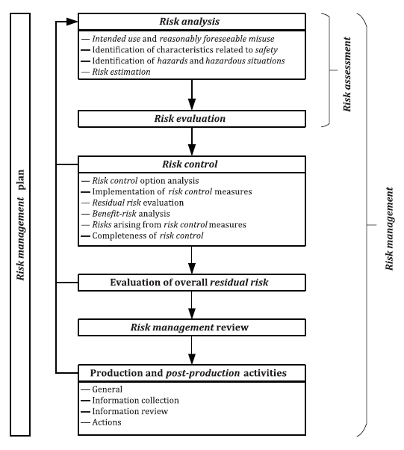

Appendix 2 : Example of Hazards

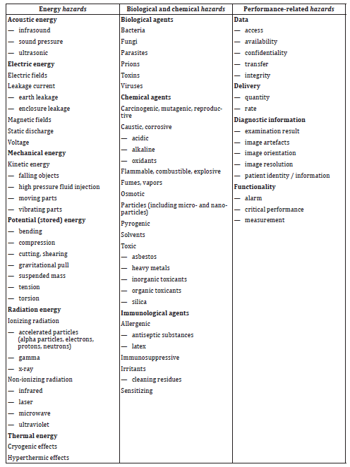

Appendix 3 : Examples of Events and Circumstances

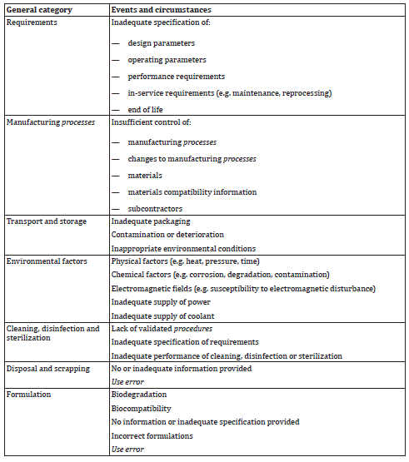

Appendix 4 : Design (DFMEA) Risk Assessment on Severity Ranking and Probability Level Table

Table 1: Qualitative Severity (S) Ranking
Term | Ranking | Problem Description
Catastrophic | 5 | Death
Critical | 4 | Permanent impairment or irreversible injury
Serious | 3 | Injury or impairment requiring medical or medical intervention.
Minor | 2 | Temporary injury or not requiring medical attention.
Negligible | 1 | Inconvenience or temporary discomfort

Table 2: Semi-Quantitative Probability (P) level
Rank | Occurrence | Criteria: Frequency Rank | Probability
5 | Frequent | Hazard occurred is almost inevitable from similar activities or processes | 1 in 1,000 pcs
4 | Probable | Hazard often occurred from similar activities or processes | 1 in 5,000 pcs
3 | Occasional | Hazard occasionally occurred from similar activities or processes | 1 in 50,000 pcs
2 | Remote | Hazard seldom occurred from similar activities or processes | 1 in 500,000 pcs
1 | Improbable | Hazard rarely occurred from similar activities or processes | 1 in 1,000,000 pcs

Appendix 5 – Process (PFMEA) Risk Assessment on Severity Ranking, Probability and Detection Level Ranking Table

Table 1: Qualitative Severity (S) Ranking
Term | Ranking | Problem Description
Catastrophic | 5 | Death
Critical | 4 | Permanent impairment or irreversible injury
Serious | 3 | Injury or impairment requiring medical or medical intervention.
Minor | 2 | Temporary injury or not requiring medical attention.
Negligible | 1 | Inconvenience or temporary discomfort

Table 2: Semi-Quantitative Probability (P) level
Rank | Occurrence | Criteria: Frequency Rank | Probability
5 | Frequent | Hazard occurred is almost inevitable from similar activities or processes | 1 in 1,000 pcs
4 | Probable | Hazard often occurred from similar activities or processes | 1 in 5,000 pcs
3 | Occasional | Hazard occasionally occurred from similar activities or processes | 1 in 50,000 pcs
2 | Remote | Hazard seldom occurred from similar activities or processes | 1 in 500,000 pcs
1 | Improbable | Hazard rarely occurred from similar activities or processes | 1 in 1,000,000 pcs

Table 3 : Detection (D) Ranking

Ranking | Criteria
8 | No current process controls
7 | Through calibration activities
6 | Through machines preventive maintenances
5 | Daily verification of production machine / equipment
4 | Production start-up checks
3 | QA sampling process (few samples volume)
2 | QA sampling process (increase samples volume)
1 | 100% visual inspection

